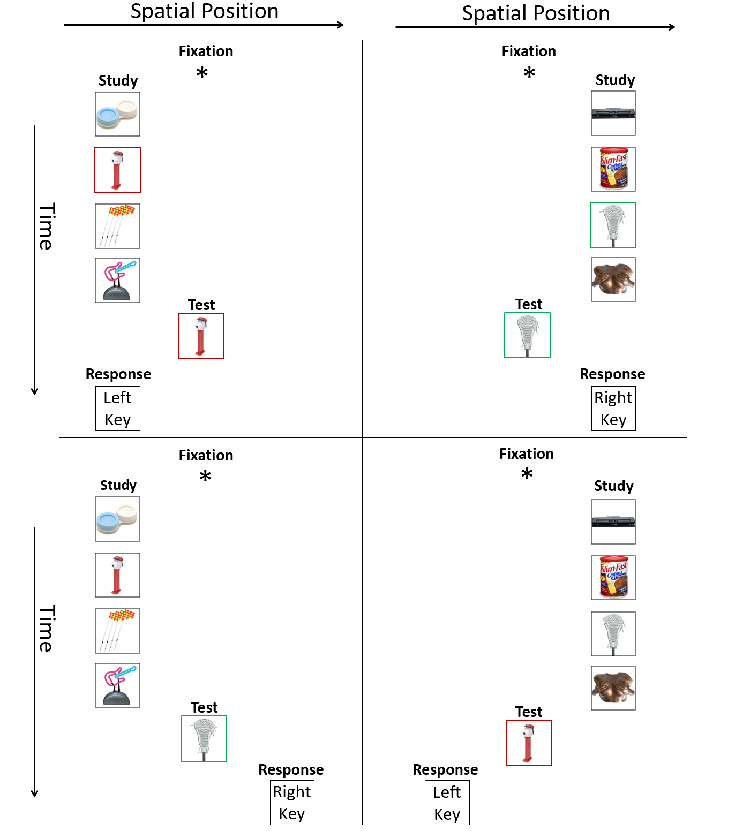

# Experiment 1

This study examined CM, VM, and a condition that used both CM and VM pictures in the same trials.

## Method

**Participants** Undergraduates participated for class credit in single sessions lasting less than one hour. There were three groups of participants, trained respectively in a pure CM condition, with 28 participants, a pure VM condition, with 28 participants and a Mixed VM/CM condition, with 30 participants. Of those two had to be rejected after inspection of their results due to performance near chance, one in pure CM and one in pure VM.

**Stimuli and Apparatus** The stimuli were composed of 2,400 daily life pictures from the website of Talia Konkle (Brady, Konkle, Alvarez, and Olivia, 2008). Each image subtended a visual angle of approximately 7 degrees and was displayed on the center of a grey background. The experiment was conducted with MATLAB Psychophysics Toolbox (Brainard, 1997) on PCs. All participants were tested in private, sound-attenuated booths.

**Procedures** Two, four of eight pictures were presented sequentially for study, and then a single picture was tested, half the time from the list (termed a target or OLD item) and half the time not from the list (termed a foil or NEW item). The side used for presentation was chosen randomly from trial to trial. The participant responded with an F key (on the left) for any target (OLD test picture) presented on the left of fixation, and responded with the J key (on the right) for any target presented on the right of fixation. The participant responded with the opposite key for any foil test. *Timing and Session*: Trials were self-initiated. A fixation point (*) appeared on the center of the screen for 0.5 seconds prior to the first picture. Pictures were presented for 0.5 secs with 0.1 secs between pictures. After the last picture a new fixation point ("+") appeared on the center screen for 0.5 second, followed by a test probe that appeared on the center of the screen. The test probe stayed on the screen until the key response was registered. Then there was a blank screen for 0.5 secs, and then feedback ("correct" or "incorrect"), which lasted for 1 second.

There 9 blocks of 25 trials each, taking about 45 minutes. The first block was considered as a training block that was not included in the final analysis. CM: Eight of a participant’s set of pictures were assigned to be targets presented for study always on one side of fixation and the other eight pictures were assigned to be targets presented for study always on the other side of fixation. The pictures that served as targets on one side served as foils on the other side. A target was chosen randomly from those presented; a foil was randomly selected from the set used as targets on the other side of fixation. VM: On each trial, two four or eight pictures were selected randomly from that participant’s set and studied. A target was chosen randomly from the presented set and a foil was chosen randomly from all the pictures not presented. Mixed VM/CM: On each trial half the studied pictures were VM, and half CM – see previous.

**Results**

Data from trials where response occurs before 200 ms or after 4000 ms were excluded (~1% of the data). Figure 2 gives the median response time of correct trials in the top panel and the probability of error in the bottom panel for CM, Mixed CM/VM, and VM conditions.

1. The CM and VM data are similar to those in previous studies with standard probe-recognition tasks (e.g. Nosofsky et al. 2014a): CM performance is faster, has lower error rate, and smaller effects of set size